Bellabeat Project Documentation

Business task
Bellabeat aims to understand how consumers use smart devices to track activity, sleep, and wellness habits. By analyzing public smart device data, the here is to identify trends that can be applied to Bellabeat products, informing marketing strategies that better engage users and drive growth.

Data sources used
- Fitbit Fitness Tracker Data (CC0 Public Domain)
- Source: Kaggle (Julen Aranguren)
- Description: Personal fitness tracker data from 30 Fitbit users collected via Amazon Mechanical Turk between 03.12.2016 and 05.12.2016. Includes minute-level and daily summaries of activity, heart rate, and sleep monitoring.
- Purpose: To analyse trends in smart device usage, focusing on activity, and sleep patterns. These insights will inform marketing strategies for Bellabeat wellness products.
- Credibility: Public dataset with anonymized user data. The sample is small and self-selected, so the results may not fully represent the general population.
- License & Privacy: CC0 Public Domain; no personally identifiable information included.

Cleaning and processing steps
  - Activity Data Cleaning
- File: 01_activity_data_cleaning.py
- Steps:
  - Load raw CSV.
  - Inspect dataset for shape, nulls, duplicates, and unique values.
  - Convert ActivityDate to datetime; handle invalid dates with errors='coerce'.
  - Remove duplicates.
  - Reset index.
  - Save cleaned CSV.
  - Sleep Data Cleaning
- File: 02_sleep_data_cleaning.py
- Steps:
  - Load raw CSV.
  - Rename SleepDay → SleepDate.
  - Convert to datetime and extract only the date.
  - Remove duplicate records per user per day.
  - Calculate SleepLatency = TotalTimeInBed - TotalMinutesAsleep.
  - Check for negative values (none found).
  - Reset index.
  - Save cleaned CSV.
  - Merging Activity and Sleep Data
- File: 03_activity_sleep_merging.py
- Steps:
  - Load cleaned activity and sleep datasets.
  - Align date formats (ActivityDate & SleepDate).
  - Merge datasets using inner join on Id and Date.
  - Inspect merged dataset for nulls, duplicates, and shape.
  - Save final merged CSV (activity_sleep_merged.csv).
- Notes / Considerations:
- Only included users with both activity and sleep data to ensure valid comparisons.
- Focused on April–May 2016 because data coverage for all users is incomplete across the full period. Therefore, final user count is 24.
- Derived features like SleepLatency allowing for deeper behavioral insights (e.g., effect of daily activity on sleep onset).

Analysis summary
The dataset was aggregated at both daily and user levels to identify patterns in activity, sleep, and engagement.
- Key analysis steps:
- Calculated average and median values for: Daily steps, Sleep hours, and Sleep Latency per user.
- Created a User Tracking Summary table including: User Id, Tracking Days, Average Steps, Steps Category, Engagement Levels, Average Sleep Hours, Meets Sleep Recommendation, and User Label or Rank
- Classified users into categories:
- Activity Levels: Based on average daily steps per user
Sedentary ([Avg Steps] < 5000),
Low Active (5000 <= [Avg Steps] <= 7499),
Somewhat Active (7500 <= [Avg Steps] <= 9999),
Active (10000 <= [Avg Steps] <= 12499),
Highly Active ([Avg Steps] >= 12500)
- Engagement Levels: Based on number of tracking days per user
High Engagement (25 to 31 days)
Moderate Engagement (15 to 24 days)
Low Engagement (1 to 14 days)
- Sleep Recommendation: Users meeting ≥7 hours of recommended sleep
- Observations:
- Only 41.67% of users fall into the High Engagement category.
- Only 45.83% of users meet recommended sleep duration.
- Sleep latency varies significantly, with some extreme values indicating inconsistent sleep quality.
- There is no strong correlation between higher steps and better sleep duration.

Visualizations
A Power BI dashboard was created to communicate insights effectively. The dashboard includes:
- Key Visuals:
- User Engagement Distribution (Donut Chart)
Shows proportion of low, moderate, and high engagement users.
- Activity Level Distribution (Donut Chart)
Categorizes users based on average daily steps.
- Average Daily Steps v/s Average Daily Sleep Hours (Scatter Plot)
Used to explore relationship between physical activity and sleep duration.
- Average Daily Hours per User (Clustered Column Chart)
Includes reference range for recommended sleep (7–9 hours).
- Average Sleep Latency per User (Clustered Column Chart)
Includes threshold line at 20 minutes (healthy latency).
- KPI Cards:
- Total users
- % Highly Engaged Users
- % Users Meeting Sleep Recommendation
- % Users Meeting Step Goal of 10,000
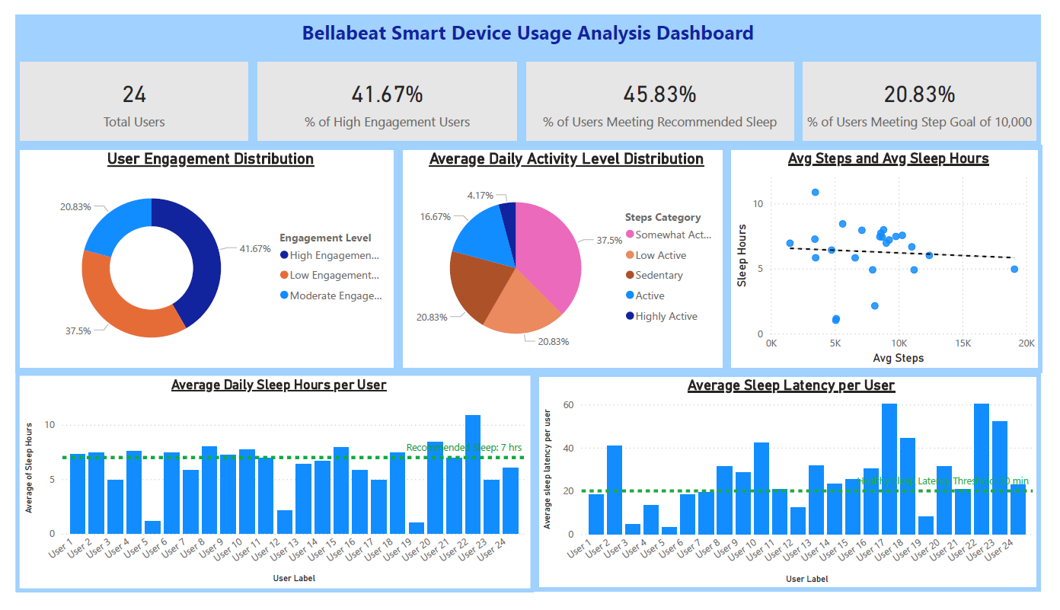

Key findings and recommendations
- Key Findings:
- User Engagement is Uneven
While some users track their activity consistently, others show low engagement. Low engagement may indicate either limited device usage despite being active or reduced participation in physical activity. For the purpose of this analysis, it is assumed that the absence of recorded data reflects no physical activity.
- Moderate Activity Dominates
Majority of users fall into “Low Active” or “Somewhat Active” categories.
Only a smaller segment achieves ≥10,000 steps/day.
- Weak Relationship Between Activity & Sleep
Increased steps do not strongly correlate with better sleep duration.
Suggests other factors (stress, routine, lifestyle) influence sleep.
- Sleep Goals Not Consistently Met
Many users do not achieve the recommended 7–9 hours of sleep.
Indicates opportunity for sleep-focused interventions.
- Sleep Latency Variability
Most users fall within healthy latency (<20 min), but some outliers indicate poor sleep quality.
- Top 3 Recommendations:
- Improve User Engagement
Encourage consistent device usage through: Notifications, Progress tracking, or Habit-building features. Focus on converting low-engagement users into regular users.
- Encourage Higher Activity Levels
Introduce step goals, reminders, and gamification.
Target “Low Active” users with nudges to reach ≥10,000 steps/day.
Use personalized insights to motivate users.
- Promote Sleep-Focused Features
Highlight sleep tracking, relaxation, and mindfulness features in Bellabeat products.
Educate users on improving sleep habits.
Use in-app insights to encourage consistent sleep routines.
- Future Improvements:
- Include larger and more diverse datasets for better generalization.
- Incorporate additional metrics such as: Heart rate, Stress levels, or Calories burned
- Perform time-based analysis (weekly/monthly trends).

